**Hotel Management System Overhaul**



***Use Case Summary Document***

**Version No. 1**

**Project Document Revision History**

|  |  |  |  |
| --- | --- | --- | --- |
| **VersionNumber** | **Date** | **Revision Author** | **Description of Revision** |
| 1 | 6/11/20 | Jeffrey Fishman, Monier Abdullah, Khalid Saeed, Peter Schubert | Initial version of use case summary |
|  |  |  |  |

|  |
| --- |
| **Table of Contents** |

**Introduction** **3**

**Project/Application Actors** **4**

**Use Case List** **5**

**Use Case Diagram(s)** **6**

**Use Case Summary** **6**

**Use Case Summary Review and Signoff** **8**

# **Introduction**

This document captures BUSINESS requirements at a high level by identifying ALL the use cases in a project/application.

Write a few paragraphs describing the purpose of the project/application in the Introduction.

The purpose of the new hotel booking system is to replace the old and outdated hotel booking system. The old system is outdated, slow, inefficient and the employees have to put the customers on hold. The employees also have to work with multiple screens to pull up customer information about the reservation in order to cancel or rebook.

The new system will allow for a smooth experience for both the customers and employees. The new system will allow for outside bookings and allow the implementation of a reward system. Also employees will be able to view metrics of various customers.

The customer will be able to create and login to their account to view hotels, book a room, view existing bookings, and view collected metrics. The hotel booking system will allow administrators to view bookings and metrics, and be able to make changes to a customer’s reservation. The database will be used to check customer and hotel metrics such as customer’s login information, reservation preferences, hotel room availability, changes to reservations, reward points, and confirm bookings.

# **Project/Application Actors**

An actor is someone or something (e.g. application system) outside the system or business that interacts with the application. List the actors involved in ANY use case. Actors should be a person, system, or time.

|  |  |
| --- | --- |
| Actor Name | Description |
| Customer | Primary Actor: interacts with the system to login, book stays, view reward points, edit phone#, address. |
| Employee/Administrator | Primary Actor: interacts with system to cancel and review reservations, view summary reports |
| Database | Secondary Actor: interacts with system to store:  Customer: record customer information,total reward points, reservation details (start and end dates, room type)  Hotel: hotel availability,hotel locations, room types, room id, room cost, points per room  Transaction: Transaction#, Customer UID, payment type, total payment, reward points, start and end date. |
| Management System | Interacts with the database to store, collect, or manipulate data within the database’s tables and present back to the Customers and Employees / Administrators |

# **Use Case List**

List ALL use cases identified for the project/application.

* Creates a new account for use with the Management System - Customer, Employee, and System
* Logs in/Logs out to the Management System- Customer, Employee, System
* Verifies username and password of user logging in from Management System- System
* Modifies Account- Customer, Employee, System
* Books a hotel room with the Management System-Customer, System
* View individual customer reservation information- Customer, System
* Views a all existing reservation with the Management System- Employee, System
* Modifies Customer bookings with the Management System-Employee, System
* Cancels an existing reservation- Employee, System
* Views collecting Hotel Room booking metrics with the Management System- Employee
* Calculates and updates Metrics-System
* Process Payment-System

# **Use Case Diagram(s)**

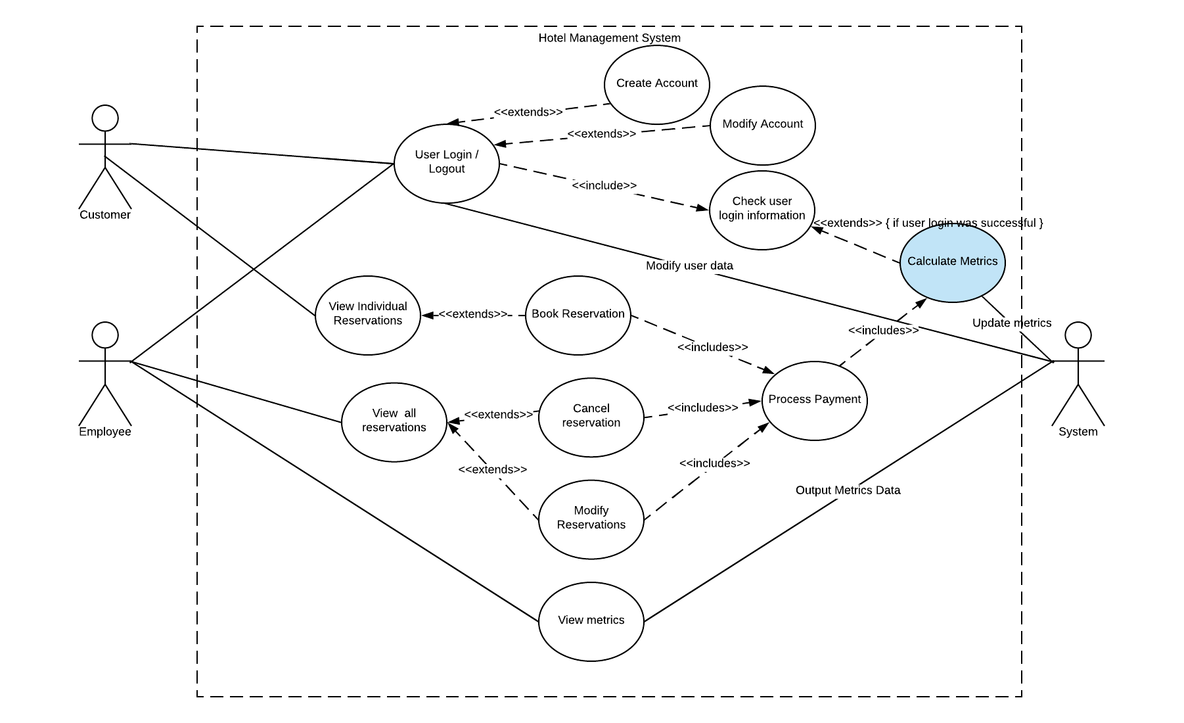

# **Use Case Summary**

1. Create Account
   1. A new user elects to create an account on the system. The user inputs their data, and the system checks the data for proper formatting. If the data is improper, it notifies the user and asks for proper data. If it’s proper, it stores it and a new user is created. The new user is then able to log in to the system and perform various actions successfully.
   2. Primary Actors: Customer, Employee/Administrator
   3. Secondary Actors: System
2. Modify Account
   1. This use case describes how the customer will be able to modify their account information such as their first name, last name, address, phone number. The customer information is stored in the database, when the customer logs into their account and clicks on a menu item to modify their information, the customer details will be brought up for the customer to view and/or edit and be able to save it to the database.
   2. Primary Actors: Customer
   3. Secondary Actors: System
3. User Login/Logout
   1. User Login and Logout describes how employees and customers will be able to login and logout of their respective accounts. When a user logins in, their user credentials entered in will be checked with the database to see if they match. Once logged in, based on their individual profile type (customer or employee), they will be able to view and fulfill their respective functions. Once finished the system and logged out, they will be redirected to the main login in page for another user to login
   2. Primary Actors: Customer, Employee/Administrator
   3. Secondary Actors: System
4. Check User Login Info
   1. Users must have initiated a log in prior to this use case executing. Once a user submits their username and password information for logging in, the System will check its stored data to ensure a matching user entry exists. If it does not exist, notify the user that their credentials are invalid, and ask for valid data. If it does exist, authenticate the user and allow them to complete the login process, allowing them access to the system’s functionality.
   2. Primary Actors: Customer, Employee/Administrator
   3. Secondary Actors: System
5. Book Reservation
   1. An authenticated user can view available hotels and rooms to book, and submit a request to the system to reserve a specific room to their account. The user will select preferences for start and end dates, and the number of people for the reservation. The system will check if the room is available for the requested start and end dates and the specified number of people. If available, then the system will ask for payment. On successful payment processing, reserve the room to the current user, and remove it from the list of available rooms from other users.
   2. Primary Actors: Customer
   3. Secondary Actors: System
6. Modify Reservations
   1. Modify Reservations describes how employees and customers are able to make changes to existing reservations. When a user logs in, they are able to choose the option to modify a reservation which allows them to change the time/date of the reservation, the room type, the number of people, and preferences. After they make changes to the reservation, they will be able to save or discard changes made to the reservation. A customer is able to modify their own reservation, while the administrator can modify any reservation.
   2. Primary Actors: Customer, Employee/Administrator
   3. Secondary Actors: System
7. Cancel Reservations
   1. Cancel Reservation describes how employees and customers are able to terminate a previously confirmed reservation. When a user logs in, they are able to choose the option to cancel a confirmed reservation which will delete all aspects of their reservation. If the user would like to reverse the cancellation, they will have to create a new reservation. A customer is able to cancel their own reservation, while the administrator can cancel any reservation.
   2. Primary Actors: Customer, Employee/Administrator
   3. Secondary Actors: System
8. View Reservation
   1. View Reservation describes how employees and customers are able to view the information regarding their reservation. The information consists of the room number that the customer reserves, the date of when the reservation is, cost of the reservation, and the hotel that is being reserved at. When a user logs in they are able to choose the option to view the reservation which will grant all of the information shown above. An employee has the option to view other people’s metrics while a customer is only able to view his/her own reservation.
   2. Primary Actors: Employee/Administrator (Unlimited), Customer (Limited)
   3. Secondary Actors: System
9. Calculate Metrics
   1. With an authenticated user, on a successful payment or login to the system, calculate and create or update the number of times the user has logged in, the number of times a specific hotel has been reserved, and the number of times a specific hotel room has been reserved.
   2. Primary Actors: Employee/Administrator
   3. Secondary Actors: System
10. View Metrics
    1. View metrics describes how employees and customers are able to view information regarding their metrics. The following metrics can be viewed which are reward points, most popular hotel, revenue, number of times logged in, the rooms that are most commonly booked, most stay locations, most visited customers, and most popular rooms most customers book. These metrics will enable the administrator to give proper feedback to customers and improve the overall experience.
    2. Primary Actors: Employee/Administrator (Unlimited)
    3. Secondary Actors: System
11. View Individual Reservations
    1. Customers will be able to view the details of their current and past reservations, including the hotel location, payment amount, and rewards details
    2. Primary Actor: Customer
    3. Secondary Actor: System
12. Process Payment
    1. The system will process the payment or refund to or from the customer based on whether the customer pays via an electronic payment or uses their own points. Once a customer pays for their room, the system will look up the credit/debit card information and charge it to the account. If the customer wants to use their points, the amount due will be deducted from their total reward points amount. If reservation cancelled by the employee, the system will refund the amount of points to the customer’s credit card or refund the points
    2. Primary Actor: Customer, Employee
    3. Secondary: System

# **Use Case Summary Review and Signoff**

|  |  |  |  |  |
| --- | --- | --- | --- | --- |
| Review and Signoff of the Use Case Summary | | | | |
| Name | Project Team Role | Signature | Date | |
| Peter Schubert | Team Lead /Software Developer | PS | 6/11/2020 | |
| Monier Abdullah | Software Developer | MA | 6/11/2020 | |
| Khalid Saeed | Software Developer | KS | 6/11/2020 | |
| Jeffrey Fishman | Software Developer | JF | 6/11/2020 | |